iugihguhgk

Database- Compare Files

# User Guide



Written by Sarah Frearson

**Compare Files**

* Copy and paste product information from supplier in to “Compare File” Template.

**To access the Compare File Template press the Ctrl button and click on the link below.**

I:\Andrea\Training Manuals\Database\Compare File Template - remember to save as CSV.xlsx

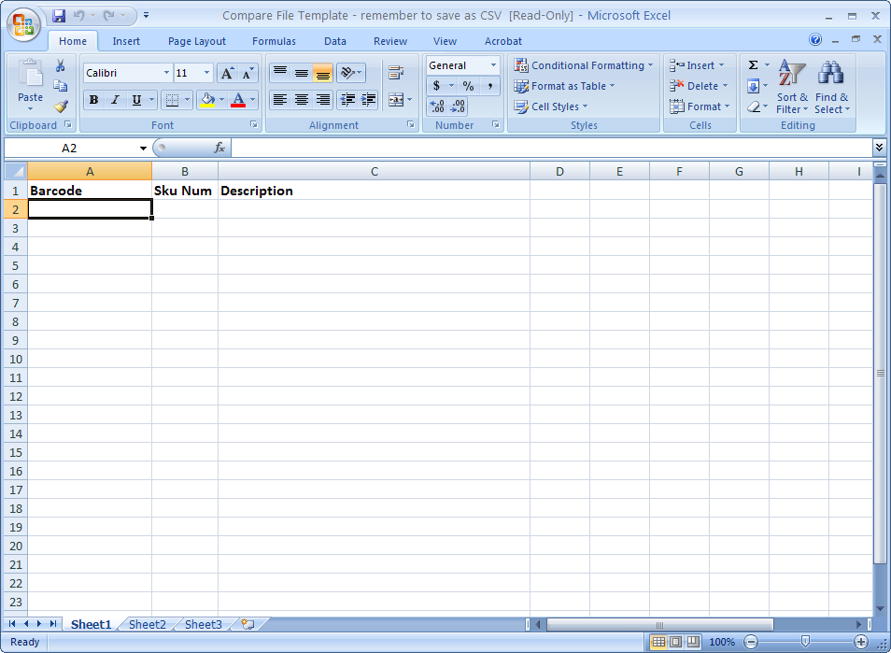

* When finished make sure to save it as a CSV doc. in My computer – Public on Tl-sbs’(I:) drive – I.T – Leah Compare - Books

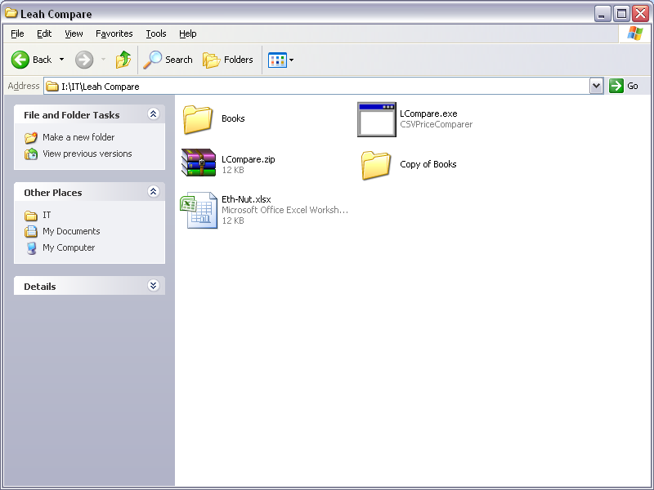

* From the Windows Start Key – Go to My Computer, Public on Tl-ad1’(I:) drive – I.T – Leah Compare
* Then double click ‘**LCompare.exe’**



* Click on Browse - My computer – Public on Tl-sbs’(I:) drive – I.T – Leah Compare – Books - Okay
* Click Compare

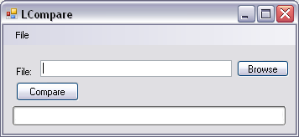

* When finished the new file will be called the same as you have named it, with ‘Final’ at the end of it. This will be in the ‘Books’ folder
* Open up the ‘Final’ doc
* Format the barcode to number (no decimal point)
* Save the file as Excel workbook in your designated folder (my documents)